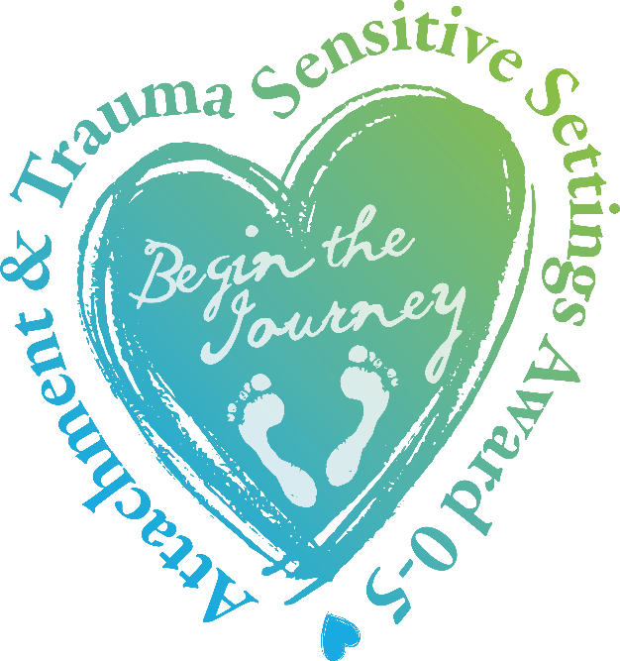

Attachment and Trauma Sensitive Settings Award 0-5 (ATSSA 0-5)
A framework of support and understanding for EYFS Settings and Nursery Schools within which children who have experienced adversity, can heal, thrive, play, and learn.

The Attachment and Trauma Sensitive Settings Award 0-5 (ATSSA 0-5) aims to provide a framework of support and understanding for Early Years Settings, including Day Nurseries, Pre-Settings and Playgroups within which babies and young children who have experienced adversity, can heal, thrive, play, and learn. These will include those who are adopted from care, in the care of the Local Authority, or live with parents who cannot, for whatever reason cannot adequately meet their needs.
The Award aims to ensure that everyone within the setting has a good knowledge of the needs of babies and young children who have experienced adversity and of the strategies and resources that are available to meet such needs. This awareness of how to support emotional needs and development is a key factor in promoting positive learning and mental/physical health outcomes for all children.
The Attachment and Trauma Sensitive Settings Award is an external sign of recognition of the commitment of EYFS Settings and of the steps they take to develop a culture of compassion and nurture. The award is issued only to those settings that can demonstrate that they have met its rigorous quality standards and can maintain them over time.
Above all, achieving the Attachment and Trauma Sensitive Settings Award 0-5 communicates to all interested parties, including children, parents and carers, staff, Governors and other stakeholders within and beyond the local community that the setting is committed to embracing inclusion at its best, successfully removing barriers to learning and healthy development, and participation in the life of the setting
The process is designed to be easily accessible in terms of cost, time and evidence gathering. We hope that all settings registering for the Award will find the journey easy to navigate and supportive of developing best practice. Please read on for more information.

Attachment and Trauma Sensitive Settings Award (ATSSA)
A three year process with three levels of achievement:
Bronze - Attachment and Trauma Aware (ATA)
Silver - Attachment and Trauma Friendly (ATF)
Gold - Attachment and Trauma Committed (ATC)
Some settings may enter the process at the ATA or ATF level, and providing they can evidence this, the ATA or ATF will be awarded
JNTC can provide training for at all levels. Settings may receive training from other bodies, but the content of such training will be scrutinised to ensure that key components are covered, and informal interviews with selected members of staff across all levels will be carried out.
Documented evidence and witness statements will be accepted as evidence, but at each level, a final verification visit from approved persons to observe and discuss practice will be mandatory. During the ATC phase, two visits will take place, one at very short notice.
Administration costs will be kept to a minimum to ensure that as many settings as possible apply for the award. Costs for Consultancy days will be discounted, as will training, for settings applying for the award at any level.
Settings can buy in to a full programme of support if they wish, and an example of a Bronze package can be seen below. Please note that this is an example only, and some settings may only need or choose a half-day consultation with the Awarding Body to conduct the verification visit. The final content of the programme of support will be agreed between the Lead Consultant and the Setting Representative, usually, but not always, the Headteacher, Principal or Manager.

Example of Attachment and Trauma Sensitive Settings Award 0-5 -Training and support programme Year 1: Bronze - Attachment and Trauma Aware
Overview
Training days x 1 (could be 2x3 hour sessions)
Audit x 1
Verification x 1
Training
Training will be delivered early in the process to ensure all staff have basic understanding about the impact of developmental, relational trauma.
- Attachment Demystified (or similar from approved trainer): Introductory bespoke training covering the formation of attachment, impact of trauma, developmental vulnerabilities and setting as a safe base, tailored to meet the specific training needs of practitioners within a setting or cluster of settings (six hours).
- Bespoke training for SL/MT focused on strategic planning for becoming an Attachment and Trauma Sensitive Setting 0-5 (minimum half day or twilight – three hours)
- ENGLISH, WELSH AND NORTHERN IRISH SETTINGS ONLY - Training for Governors: NICE Guidelines on attachment in children who are adopted, in care or at risk; overview of attachment; implications for settings (minimum half day or twilight). Alternatively, Governors could attend whole setting and/or SL/MT training to achieve this criterion
NB Settings are encouraged to invite colleagues from other settings to training days to offset costs

Observation and consultation
Initial Audit Visit: Observations will be carried out across the setting, general recommendations will be made about developing Attachment and Trauma Sensitive practice. Consultation and discussion with leaders, managers and key staff, as appropriate will take place, and a comprehensive written report regarding issues and recommendations, with action points, will be provided following the visit.
Observation and consultation days may incorporate training for leaders, managers, governors etc., and/or Key Worker support. This will comprise training to develop understanding of developmental vulnerabilities and facilitate the development of authentic attachment relationships. They will be supported in developing individual action plans, with reference to concerns, targets and actions, with the aim of reducing unwanted behaviour and increasing the children’s’ perception of safety, thus, over time, raising children’s’ levels of ability to access the activities and social relationships within the setting.
Verification Consultation Visit: When the Evidence Folder has been submitted and scrutinised, a representative of the Awarding Body (usually Jennifer Nock), will visit the setting in order to verify the information submitted, prior to formally granting the Award.
Renewal of status of ATA and ATF
For settings not wishing to progress to Silver - ATF or Gold - ATC, the Award will be monitored and renewed biennially, through a one day visit for discussion with key staff, including SLT, evidence of ongoing CPD, updated documents and policies and stakeholder feedback.
When settings register for the Gold - Attachment and Trauma Committed Award, they will be monitored over a further one year period and (usually) two visits will take place, one at very short notice. Providing consistency of attachment and trauma sensitive practice is evidenced, Attachment-Committed Status will be awarded. The Status will be monitored and renewed biennially, through a one day visit for discussion with key staff, including SLT, evidence of ongoing CPD, updated documents and policies and stakeholder feedback.
costings
Fees for all training and consultancy services will be discounted by 20 per cent for settings working towards the Award at any level.
Service | Usual cost | -20% discount
Training full day | £980+VAT (£1176) | £784+VAT (£940.80)
Training half day/twilight | £680+VAT (£816) | £544+VAT (£652.80)
Consultancy (between 3 to 7 @ £100+VAT per hour) | Max £700+VAT (£840) | Max £560+VAT (£672)

The Award itself costs £300+VAT (£360), £100+VAT payable upon registration, and final £200+VAT on achieving the Award.
As noted previously, settings can opt for as much or little support and training as they require. Some settings may want a full package of extended training and advisory visits, while others may wish to register for the Award, complete and submit the Evidence Folder, and receive a final, three-hour verification visit. In the latter case the total cost would be £300+VAT for the Award fee and £240+VAT for the verification visit.
Telephone and email support will be available, at no additional cost, throughout the process.

Acknowledgements
Jennifer Nock Training and Consultancy would like to thank the following people for their contributions to the development of the Award Criteria:
Jennifer Jones, MBE, Inspired Foundations; Rohit Naik, Headteacher, Hope School, Liverpool; Maxine O’Neill, Deputy Headteacher, Hope School, Liverpool; Matt Darkins, Attachment Lead Practitioner, Hope School, Liverpool; Louise Howard, Deputy Headteacher, Crossley Fields School, Mirfield; Tracy Dell, Headteacher, Crossley Fields School, Mirfield; AnneMarie Pearson, Headteacher, St Ignatius Primary School, Wishaw; John McDowall, Headteacher, Gretna Primary School, Gretna; Sue Conron, Headteacher, Duke St Nursery, Chorley.

Award Administrator: Bridie White
Email: Bridiewhitejntc@hotmail.com
Phone 07947 555 329 or 07983 482 804
Website: http://www.attachmentandtraumasensitiveSettingsaward.com/

