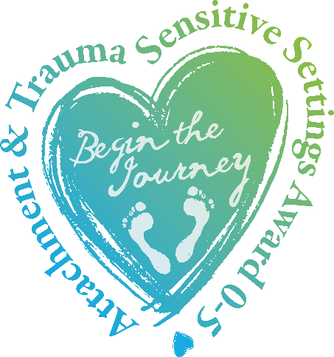
Registration Form
Attachment and Trauma Sensitive Settings Award 0-5

Name of Setting: ………………………………………………………………………………….
Postcode of Setting: ………………………………………………………………………………
Contact Name: …………………………………………………………………………………….
Position: ………………………………………………………………………………………………
Daytime Tel No: …………………………………………………………………..………………
Email address: ………………………………………………………………………………………

Which Award Level are you Registering for?
Bronze - Attachment and Trauma Aware (ATA)
Silver - Attachment and Trauma Friendly (ATF)
Gold - Attachment and Trauma Committed (ATC)

Data Protection Act 2018
The information you provide on this form will be processed by the ATSSA and used to process your application for the Award. This information will not be shared with any other parties without your express permission.
Disclaimer
In awarding the Attachment and Trauma Sensitive Settings Award, neither Jennifer Nock Training and Consultancy, nor any of its partners can guarantee, nor be responsible for, the programmes of education provided for, or levels of attainment achieved by, learners within that settings.
Costs
Costs for Consultancy and Verification days will be discounted for all settings, as will training, for settings applying for the award at any level.
Settings can buy in to a full programme of support if they wish. The final content of the programme will be agreed between the Lead Consultant and the Setting Representative, usually, but not always, the Headteacher or Principal. Please see About the Award for more information.
Fees
Fees | Fee before VAT | Fee incl. VAT at 20%
Registration payment  Due with your application form | £100.00 | £120.00
Award payment  Due immediately before Attachment and Trauma Sensitive Settings status is awarded | £200.00 | £240.00
Consultancy and/or Verification visit  Payable within fourteen days of the visit | £100 per hour | £80 per hour
Bi-annual Maintenance Fee  Due two years after registration | £100.00 | £120.00

Certificate of Achievement
All settings who achieve the Award at any Level will receive a Certificate and those who wish will receive a Plaque at a small additional cost.
Declaration
I am applying for the Attachment and Trauma Sensitive Settings Award and agree to pay the fees as outlined above.
I understand that the initial Registration fee must be received in full before the application is processed and that all fees are non-refundable.
I understand that the final fee must be received in full before the Setting is formally presented with Attachment and Trauma Sensitive Settings status.
I undertake to adhere to all decisions made by The Attachment and Trauma Sensitive Settings Award.
Signed: …………………………………… Date: ……………………………………………
Print Name: ……………………………………………………….
Please return this form to
Bridie White, JNTC, 43 Clark Street, Stourbridge, DY8 3UF
Or email to : Bridiewhitejntc@hotmail.com
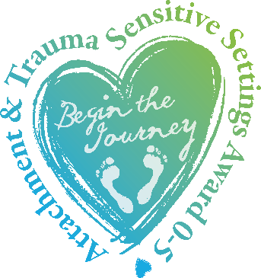
Award Administrator: Bridie White
Email: Bridiewhitejntc@hotmail.com
Phone 07947 555 329 or 07983 482 804
Website: http://www.attachmentandtraumasensitivesettingsaward.com/

